Date: March 2016
Author: Blair Van Pelt

This document provides:

- An overview of the terms and conditions of use of space in the Field,

- Information on the project assessment criteria,

- An overview on the management structure of the Field,

- A description of the communication tools which are currently available to the Field,

Management Guide
Table of Contents
1 Introduction 3
2 The Field - Terms and conditions of use 4
2.1 Practical Matters 5
2.2 Project assessment criteria 6
2.3 Additional uses of the Field 7
3 Management of the Field 8
3.1 Management committee 9
Responsibilities 9
Roles 9
3.2 User committee 10
Functional mailbox 11
WhatsApp 11
Google Drive 11
Photos 11
Contact list 11
Website 12
Content 12
Maintenance 12
Additional communication tools 12

1 Introduction

The Field is a parcel of land located at the west of the Wageningen Campus. It is a space, which is meant to give campus users a space where their innovative and informative projects can take root. The green infrastructure in the Field provides a framework that naturally separates the project areas and natural areas.

This document is intended for the management committee of the Field. This document provides:
- An overview of the conditions under which space in the Field is offered for use by Wageningen campus users,
- Information on the project assessment criteria,
- An overview on the management structure of the Field,
- A description of the communication tools which are currently available to the Field and its management committee,

2 The Field - Terms and conditions of use
This section provides information on what is offered to potential Field users, the terms and conditions under which projects may be implemented in the Field as well as the criteria under which potential projects are assessed.

The Field provides physical space (plots) of varying sizes free of charge to any campus user. This includes everyone that has a direct relation to Wageningen UR or other parties on Wageningen Campus such as students, teachers, researchers and employees who would like to use a physical space on campus to implement innovative and informative projects. The size of the plot is dependent on the desired use and the space available. Basic maintenance of the green infrastructure such as mowing of the grass and the trimming of the hedges is provided. A structure for general management whose primary role is to secure continuity and oversee interactions between projects is also set up. The management structure is a committee comprised of representatives of the projects housed on the Field, Facilities and Services, and The Green Office.

Wageningen UR’s security service does provide surveillance of the Field on a regular basis, however the Field remains an open and semi-accessible terrain. This means that the Field is open and accessible to anyone during 07:00-19.00. After 19:00 it is only accessible to Field/Plot users and the Park Manager of Wageningen Campus and people invited by them. More information regarding the accessibility and the terms of use can be found in the in the appendix.

Basic equipment such as wheelbarrow and garden tools are accessible in a lockable container shed near the Field. More information regarding the accessibility and the terms of use of the key can be found in section 2.1 Practical matters.

Projects that take place in the Field should be a manifestation of the mission of the Wageningen UR; to explore the potential of nature to improve the quality of life and Wageningen Campus: Gateway to smart food in a green world. The individuals or groups who implement approved projects in the Field must sign a user-agreement.

Financial support for projects in the Field is not provided. Consequently projects need to arrange their own funding for materials, maintenance and management of the assigned plot. The Field is not meant for commercial purposes. Potential financial gains from projects should be used to further support the intention of the Field. Records of any financial gains need to be kept and the use of such funds should be decided through the Field management committee.

The Field may be used for educational or experimentation purposes however the Field is not meant to replace any educational or experimentation facilities. To further clarify this point; the Field is not currently a formal part of any courses, study programs or educational trajectories where academic credit is offered. The Field is an open site and is not suitable for controlled experimentation due to its vulnerability to unforeseen influences.
Given that the intention of the Field is to provide space where innovative and informative projects can take root, an atmosphere of openness among the field users should be encouraged and facilitated where possible. This means that the individuals or groups with projects in the Field should be willing and able to show what they are doing with the space and share information about their projects to a wider audience.

The Field may be used as a space for developing potential entrepreneurial enterprises to test concepts and ideas. In the event that an activity becomes commercial then it is no longer seen as suitable for the Field.

In all circumstances Wageningen UR maintains ownership and rights to the grounds in the Field, however the plot users maintain the ownership of the materials in their plot(s).

2.1 Practical Matters

Key
At the moment the key for the container is accessible via the reception of Forum (building 102) and Actio (building 116). They have a list of users who are allowed to pick up the key.

The user is obliged to leave his name and contact information so that it is known who has the key at all times. If possible, add a message in the WhatsApp group if you take the key so that in case two people want it on the same day they can coordinate with each other. You can also call the reception in Forum to see if the key is available. Their number is 0317-482160. The number of the reception of Actio is 031-481514. Actio is only opened during weekdays from 8.00 – 18.00 hr.

Contact information
For all practical matters relating to the Field the first point of contact is the Park Manager of Wageningen Campus. At the moment this is Elike Wijnheijmer. She can be reached at elike.wijnheijmer@wur.nl or by calling 0317-484304

2.2 Project assessment criteria
Potential projects in the Field will be assessed based on the following criteria:

- Size of plot – The physical space in the Field is limited. As of March 2016 there are projects planned for all of area 1a and a portion of 1b and the hard pack area near the entrance (see map in annex). In area 2 an orchard will be planted of several varieties of apple trees. The intention for area 3 is to leave it as a meadow for the coming years. Small fixed points in areas 3 will be used a plant measurement stations. These points should be clearly marked on both maps and in the Field itself and remain undisturbed for the coming years.

- Use of plot – Uses of the plot space in the Field may vary greatly. However as previously mentioned the projects should be a manifestation of the mission of Wageningen Campus and should reflect the themes in which Wageningen UR operates. In addition to the nature of the project the specific use of the plot, the projected time frame, materials, contents and the intended users should be taken into consideration before a plot is granted. The intended audience for any project in the Field may be a specific subset of Wageningen Campus users, however it should be clear that the Field is open to everyone (all campus users and the wider community) within the opening times and should not exclude any groups or individuals,

- Time frame – Projects could be of varying durations of time. The diversity in projects and activities in the Field should be encouraged.

Seasonal – A seasonal project is one that would require a minimum of one complete growing season. A signed user agreement is required in all instances of a seasonal project.

Multi-year/long-term – A multi-year/long-term project is one that would require a minimum of 3+ complete growing seasons. A signed user agreement is required in all instances of a multi-year/long-term project. For multi-year/long-term projects specific attention should be paid to what the potential spatial planning or ecological implications of the planned project would be for the Field as a whole.

- Effects on the surrounding area – Projects should not have negative effects on the surrounding projects, green infrastructure or community. For example large trees that would cast a broad shadow could be considered a detrimental effect on surrounding projects that are sunlight dependent. The growth of specific plants that harbor pest species or have allelopathic properties.

The Field’s management committee will make the final decision regarding the use of a plot in the Field. Once a decision has been made by the management committee a potential user can proceed with the signing of a User Agreement which needs to be signed by Director of Facilities and Services Wageningen UR before use of the site can be granted. As time progresses and the field becomes a more established part of Wageningen Campus, the Field management committee should review and critically reflect on these criteria and make changes as necessary.

2.3 Additional uses of the Field
The Field may be used for additional purposes on an occasional or one time basis. An example of an occasional or one time activity could be a tour of the Field or a workshop that is given by a Field user or a campus user/affiliated organization who wishes to use the field as a location for a workshop or event. In any case, the use of the Field for occasional or one time activities needs to be done in consultation with the Field management committee and needs to have the written (email is sufficient) consent of the Park Manager. For the time being only small scaled events that need no permit of the municipality will be granted.

3 Management of the Field

This section provides information on the management structure of the Field, a description of the green infrastructure and project areas, and an overview of the Field management committee.

There are two distinct domains of activity in the Field, the green infrastructure and the project space. The green infrastructure consists of the trees and shrubs on the outer borders of the Field, the hedgerows separating the different project space areas and the grass meadow in area 3. The green infrastructure serves the purpose of providing distinct framework of physical barriers between sections of the Field, providing ecological functions such as providing food and habitats for local biodiversity as well as soil retention and rehabilitation. The Green infrastructure was designed by landscape architect Fiona Morris (Atelier Rabbit) in consultation with Facilities and Services as well as many local experts on infrastructure and planting schemes. In 2015/2016 the ground works and the planting of the green infrastructure were implemented. The maintenance of the green infrastructure of the Field will be implemented following Fiona Morris’s recommendations.

The project space consists of the 4 distinct open spaces (Areas 1a & 1b, 2 and 3) in between the green infrastructure borders of the Field. The purpose of the project space is to be a physical space that can be exploited by campus users for innovative and informative purposes. The contents of the project areas will be determined by whoever is implementing projects in the Field. The contents and use of the project areas may change from year to year depending on what projects are approved. As one of the terms and conditions of use a plot in the Field, the plot users are responsible for the maintenance and management of the project space and direct surroundings, i.e. mowing or clipping grass paths and borders. In addition to this, the project space users can also play a role in the maintenance of the green infrastructure by identifying the necessary maintenance. The management committee will plan, implement the maintenance in consultation with the users and decide if it will be done by WUR’s maintenance contractor or together with volunteers.

Permission to use a plot in the project space of the field is granted in approved instances and is recognized by the signing of a user agreement, which is valid for one year. The user agreement can be approved for subsequent years pending the approval of the Field management committee. Failure to comply with any of the terms and conditions for use will result in the immediate termination of the user agreement.

3.1 Management committee

Responsibilities
The day-to-day management of the Field should be carried out by the management committee. The management committee has a decision-making role. The responsibilities of this committee are as follows:
- Arrange for maintenance of the common areas and green infrastructure
- Assess potential projects based on the aforementioned assessment criteria
- Plan for future development in the Field
- Critically reflect on the criteria for use of plot space in the Field
- Ensure continuity of the Field in terms of both projects and management
- Communicate needs for the Field to Facilities & Services
- Speak on behalf of all projects in the Field
- Make arrangements for financial gains from activities in the Field and how to spend it
- Maintain communication tools, which facilitate collaboration between projects in the Field.

Roles
The Field management committee is ideally comprised of the following individuals:

- Representative from Facilities & Services – Park Manager of Wageningen Campus. His role as representative of Facilities & Services is to arrange user agreements, maintenance by WUR’s contractor, investments and other financial issues regarding the Field and represent the interests of Facilities & Services as the owner of the Field.

- Representative from WU – The WU coordinator serves as a link between students and teachers and the Field by informing the parties about activities and opportunities for new projects and collaboration between both organizations.

- Representative from WR – At least one researcher of WR shall participate in the Field management committee where they can provide insight into the operations in the Field as well as contribute to decision making about future development and potential new projects.

The Park Manager of Wageningen Campus will fulfill the role of Chair of the Field management committee. Both WU and WR representatives are involved in one or more projects on the Field. The role of Secretary should be fulfilled by one of the other representatives:

- Secretary – The secretary’s role is to keep meeting minutes, maintain the organization of the shared Google drive files, have access to the functional email inbox, content management of the website, update the Field contact list and send invitations for Field management committee meetings.

It is recommended that the management committee meet on a monthly basis or more frequently if required to fulfill responsibilities.

3.2 User committee
All members of projects that take place in the Field should also participate in a User Committee; whose role is to provide a platform for the different users of the Field to connect with each other and gather insights that needs to be shared with the Field’s management committee. The User Committee has an advisory role towards the management committee and should be pro-active in terms of following up on points/issues or actions addressed in the management committee’s meeting-minutes which they should receive.
It is recommend that this committee meets on 1-2 times per year in the spring (before the growing season starts) or in the spring and Fall (after the growing season has ended).
4 Communication

This section provides information on the communication tools that are available to the Field and its management committee. This includes a functional mailbox provided by Wageningen UR, a WhatsApp group, a shared Google drive, a website and a list of additional communication outlets useful for communicating information about the Field to the Wageningen UR community.

4.1 Functional mailbox
The Field has a functional mailbox within the Wageningen UR outlook exchange: info.thefieldwageningencampus@wur.nl. This email address is the first point of contact for the Field. For example, when a contact form or project submission is sent via the website, it will go to this email inbox.

The email address is currently ‘owned’ by Elike Wijnheijmer. It is possible for more than one person to have access to this inbox and it is recommended that at least one additional person from the Field management committee also have access to the functional mailbox, ideally the ‘secretary’ of the group. This should be a point of attention for the management group on a bi-annual basis.

4.2 WhatsApp
A WhatsApp group has been set up to facilitate quick and easy communication between Field project users. Consequently, at least one person from each project in the Field should have access to this WhatsApp group. To get access to this group, send a text message to Blair van Pelt 0630179597 asking to be added to the group. A smart phone is required to have access to this message group.

4.3 Google Drive
A Google Drive shared folder has been set up to facilitate file sharing among field users as well as serve as a repository if information collected in the Field over time. This folder can be accessed using this link.

In this shared folder the following files and folders can be found:
- Contact list
- Maps and photos
- Folder for each project
- Website
- Meeting minutes
- This document
- Additional related files

This is an unlocked folder meaning that anyone with access can edit the files stored within. As a result it is important that one person from the Field management committee take the responsibility to maintain the organization of the file and back it up at least on an annual basis.

4.4 Photos
A file with photos of the Field can also be found in the Google Drive. These photos are free to use and the photo credits can be found in the name of the file. It is recommended that a point of attention at a management committee meeting to ask all projects to any photos of their projects to this file. For future photo additions it is helpful to save the file using the same format: DD/MMM/YY_PhotoCredit_Name.

4.5 Contact list
A contact list of all Field users as well as associated people can be found in the Google Drive. This list is meant to be a living list and should be updated as need be. A shareable link to this Google spreadsheet can be found by clicking on the share icon at the top right of the Contact List. It is recommended that the secretary of the Field management committee take the responsibility to maintain this list on a bi-annual basis.

4.6 Website
The website of the Field can be accessed by using this link. The role of the Field’s website is to provide the Wageningen UR community and the wider public with information about the Field, its projects, management structure and a point of contact.

Content
The text of the website is saved in a word document in the Google drive. Changes to the document should be done using track changes so that it is easy to identify changes that need to be made on the website. Changes should be send to the Chair of the Management Committee who will ask onlinesupport@wur.nl to implement them.

4.7 Additional communication tools
Campus Life Wageningen is a Facebook page that communicates what is happening on Wageningen Campus. This is a useful communication tool when it comes to events or updates about the Field. Campus Life Wageningen can be accessed by using this link.

The editors of Resource, the independent WUR-magazine, can be accessed by using this link.

Additional Facebook and Twitter accounts that can be helpful when communicating information about the Field to the wider Wageningen UR audience can be accessed by using the links below.
- Wageningen University - Facebook
- Wageningen UR (University & research Centre) - Facebook
- Wageningen UR @WageningenUR
- Wageningen University @UniWageningen
- Wageningen UR Int. @WageningenINT

Annex 1: Openbaar versus privaat terrein op Wageningen Campus

- Alles wat rood is gearceerd is privaat terrein. Medewerkers van Wageningen UR mogen in deze gebieden altijd personen staande houden, waarvan zij vermoeden dat deze niet gerechtigd zijn/ geen toestemming hebben zich in op dat terrein te bevinden;

- Alles wat oranje en groen is gearceerd, is het publiek toegankelijke gebied ofwel openbare terrein van Wageningen Campus.

- Het oranje gebied is beperkt openbaar terrein. Na sluitingstijd van de gebouwen mogen zich daar alleen personen bevinden, die daarvoor toestemming hebben gekregen van een mandaathouder en/of locatiemanager c.q. parkmanager.

- Wat groene is gearceerd is openbaar terrein, waar iedereen mag verblijven tussen 6.00 – 24.00 uur als men zich aan de algemene regels houdt. Tussen 24.00 – 6.00 uur is het gebruik formeel beperkt tot ‘doorreis’. Voor georganiseerde activiteiten is toestemming nodig van de parkmanager. Deze regels worden gecontroleerd door de surveillancedienst c.q. het team handhaving van de gemeente.

- De zuidelijke bouwstrook wordt gezien als gebied in ontwikkeling. Bij verkoop/ verhuur van kavels wordt het oranje gedeelte ‘rood’ m.u.v. Campus Plaza, dat, gezien de beoogde functies (studenthuisvesting, winkeltjes) als openbaar terrein (‘groen’) wordt aangemerkt.

- Het terrein aan de andere kant van de Mansholtlaan is voldoende afgebakend om als privaat terrein te worden aangemerkt.

- Het gebouw van het Sports Centre de Bongerd (SCB) en de directe omgeving daarvan is privaat terrein, de directe toegangswegen zijn openbaar en het overige terrein (parkeerplaatsen en groenvoorziening) is beperkt openbaar. Het operationeel parkmanagement van de sportvelden is belegd bij hoofd SCB.

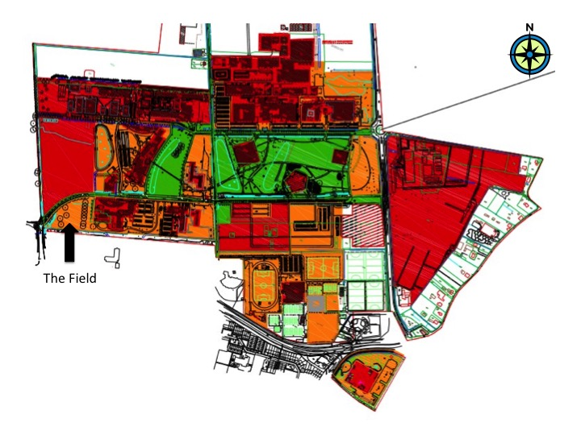

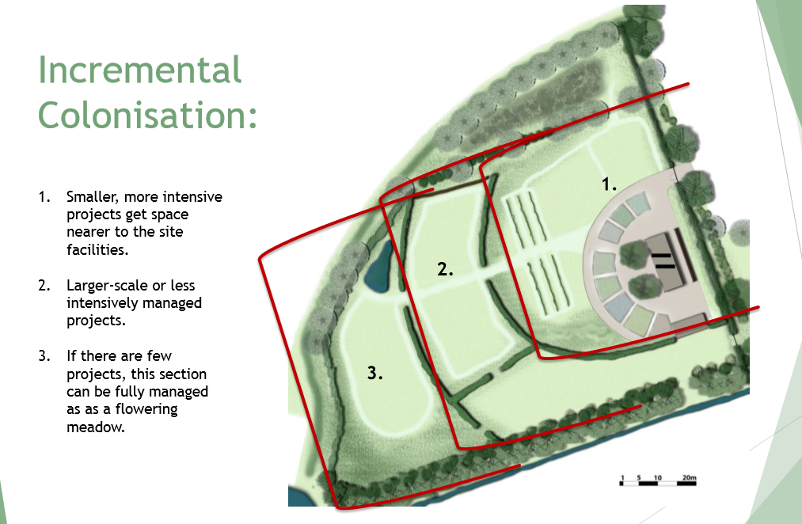

The soil in the Field has been heavily disturbed due to construction over the past few years. Consequently, the intention is to rehabilitate the soil in the Field. For this reason projects that are in the Field should also be aware of the state of the soil and ideally contribute to enhancing soil fertility on the site. In any case, when a project will no longer be using a plot, care should be taken to leave the soil covered or replant the approved meadow mixture. When the time comes, this should be point of attention for the Field management committee.
It is recommended that grass mowing and hedge trimming be done using volunteer labor and is arranged via the Field management committee. Maintenance events could be extended to include the wider community. This would mean that the maintenance is an opportunity for the wider community to learn about and participate in the Field. This would not only save money but would bring more liveliness into the space.
This could be carried out by the project users or by external contractor.

